**PROJECT TITEL : CREATING AN SPONSORED POST FOR INSTAGRAM**

**TEAM MEMBERS : R.SRIDHAR (512720105338)**

**R.KANNADHASAN (512720105312)**

**P.RAVIKUMAR (512720105330)**

**M.SANTHOSH KUMAR (512720105333)**

**BRAND NAME : EC TECHNOLOGY**

**CAREGORY : COMPUTER SERVICE**

**TARGET ADIENCE : CUSTOMER**

**E-MAIL :** [**www.ECtechnology@gmail.com**](http://www.ECtechnology@gmail.com)

**INSRAGRAM LINK :** [**https://www.instagram.com/p/CyvxQ0EvM_aHZ6HgEPD-W37j8DuQf0VWLvYl3w0/?igshid=MzRlODBiNWFlZA==**](https://www.instagram.com/p/CyvxQ0EvM_aHZ6HgEPD-W37j8DuQf0VWLvYl3w0/?igshid=MzRlODBiNWFlZA==)

**CANVA WURL :**

[**https://www.canva.com/design/DAFxIodvyO0/yY7EMvSKmDMhiAghn-cwPQ/edit?utm_content=DAFxIodvyO0&utm_campaign=designshare&utm_medium=link2&utm_source=sharebutton**](https://www.canva.com/design/DAFxIodvyO0/yY7EMvSKmDMhiAghn-cwPQ/edit?utm_content=DAFxIodvyO0&utm_campaign=designshare&utm_medium=link2&utm_source=sharebutton)

**LOGO**

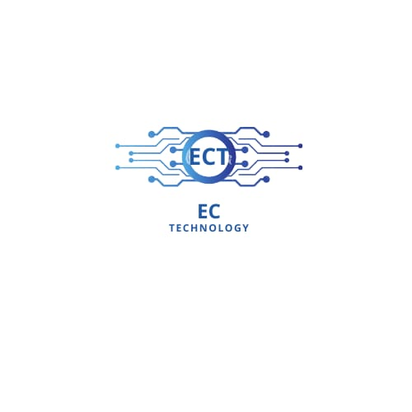

**TEMPLAT**



**ATTACHED SCREENSHOTS FOR SOCIAL MEDIA ADS**

